Effectiveness of High Dose Remifentanil in Preventing Coughing and Laryngospasm in Non-Paralyzed Patients for Advanced Bronchoscopic Procedures
Basavana Goudra, Preet Singh, Joel Reihmer ,Amit Manjunath
Background: Anesthesia for bronchoscopy presents a unique challenge. The airway response (cough and laryngospasm) to persistent irritation by the bronchoscope needs to be obtunded using drugs with minimal post procedure residual effects. The most appropriate anesthesia technique is yet to be determined.
Methods: Airway complications during advanced bronchoscopic procedures were prospectively documented over 4 months (April 2013-June 2013). Relationship between the frequency of complications and anesthesia technique were later reviewed. Neuromuscular blockers were avoided in all patients and anesthesia was maintained using a remifentanil infusion supplemented by inhalational agents or a propofol infusion. A Laryngeal mask airway was used for controlled ventilation which also served as a conduit for bronchoscopy. Anesthesiologists were unaware of the study (to avoid performance bias) and the pulmonologist was blinded to the anesthesia technique (to document unbiased procedural satisfaction scores). Procedures were divided into 2 groups based on the dose of remifentanil maintenance: Group-H (high-dose) used doses between 0.26 to 0.5 μgm/Kg/min and Group-NH used doses ≤ 0.25 μgm/Kg/min.
Results (Figures 1 -3)
A total of 75 observed procedures were divided into Group-H (42) and Group-NH (33). No statistical difference was found in demography, procedural profile, hemodynamic parameters and vasopressor used. Chi-square test showed Group-NH had significantly higher frequency of laryngospasm (P=0.047) and coughing (P=0.002). Likelihood ratio of coughing and developing laryngospasm in Group-NH was 4.56 and 10.97 times respectively. Minimum pulse oximeter saturation was statistically higher in Group-H (98.80% vs. 96.50% P=0.009). Pulmonologist satisfaction scores were significantly better in Group-H

Figure 1
Bar Graph showing mean infusion doses (with 95% Confidence intervals) in both the groups. Mean infusion dose in Group-H was 0.39±0.16 μgm.kg-1.min-1 and in Group-NH was 0.21±0.11 μgm.kg-1.min-1 (P < 0.001)
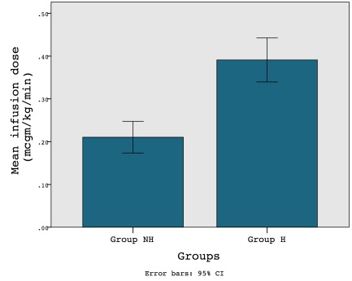
Figure 2
Box and Whiskers graphs comparing hemodynamic variable recorded in patients. Whiskers represent 95% percentile values. (*) Represent the outliers in both the groups for the variable being represented. No statistically significant difference found between the groups in baseline, minimum and maximum “mean Blood pressure” recorded during the procedure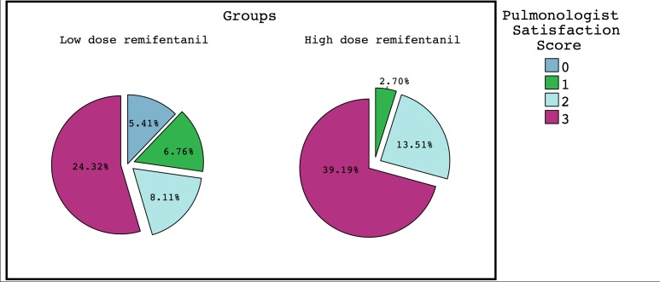
Figure 3
Pie Graphs comparing satisfaction scores as rated by the Pulmonologist evaluating procedural conditions. Median value in Group-H (3) was statistically higher than in Group-NH (4).
